**Report controlled assessment**

**Task 1:**

**Task 2:**

**Design:**

User requirements:

1. Must be able to find data from a search word
2. Must be able to display all details of person when search word is found

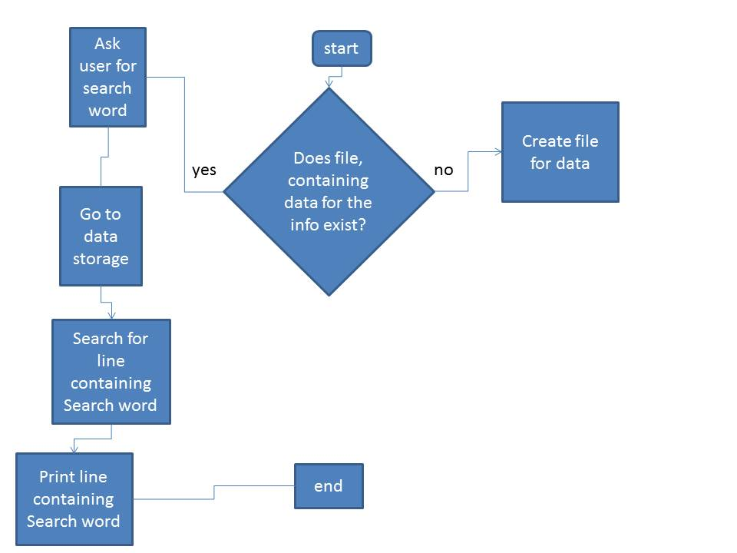

The flow chart is fairly straight forward as it consists of only one decision with two out comes so it will only have two branches to it will not be that complex. The basic outline of the flow chart is that it must search for a specific word and display the line with that word in it.

Problems: The main problem I faced was having the computer recognise what file was it was drawing the information from things ranging from the name of the file being incorrect to having the wrong kind of file to store the information. In the end I concluded that the best solution would be to make it so the program makes the data makes the file so therefore the file created would be named appropriately as the program would have named it itself and the same for the type of file. This is because if the file was created to store text then it can be accessed and therefore read.

**Development**

During the development of the code I have had to make a lot of changes regarding the creation of the file when none exist. The reason for this was that originally just going to make is so the file was created so the user can input the data directly but as it turned out it would be hard for the user to enter it in the correct format. The only solution for this was to make it so the program could ask them for the details and then enter them into the correct format.

Makes the program go to all code under it if answer is 1

This part of the code will ask the user for the information on the person they would like to add to the data base

This section is for displaying an error message if the answer is incorrect

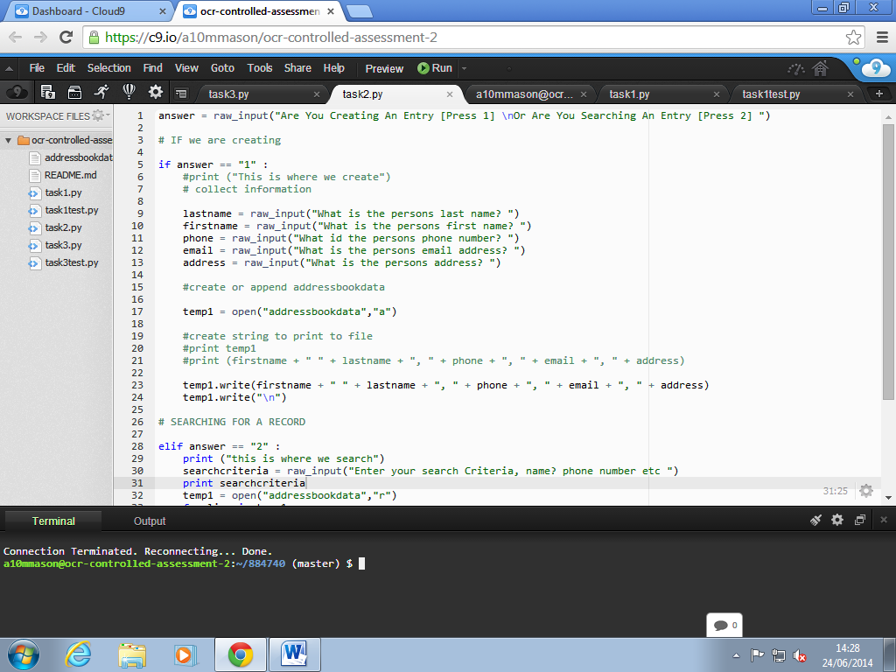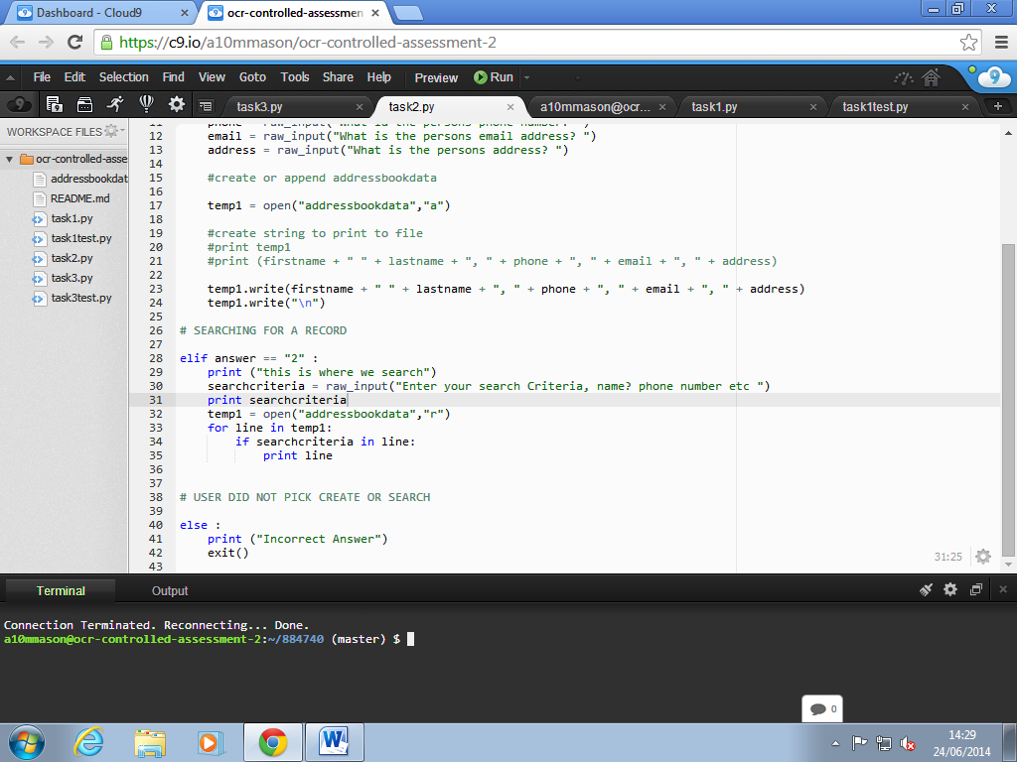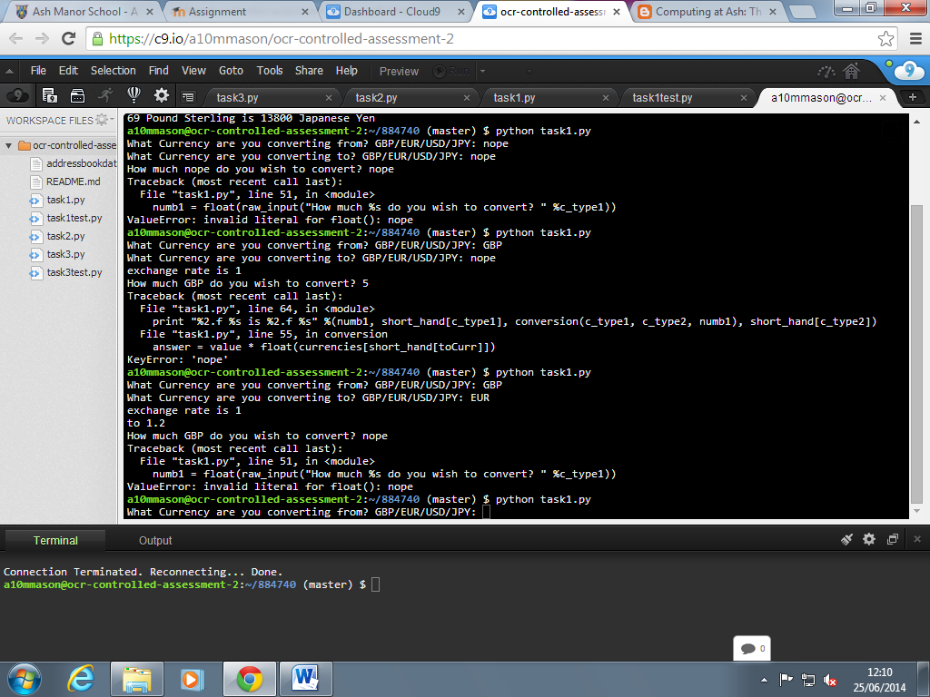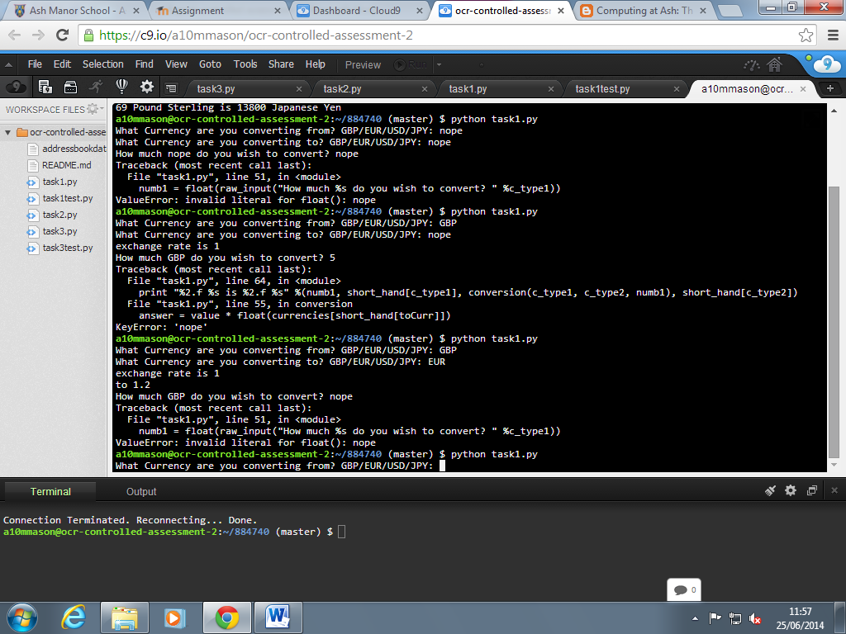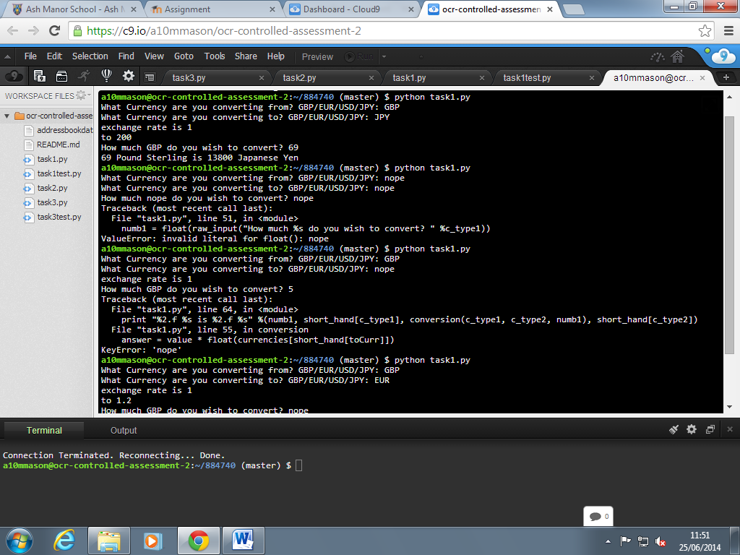

This screenshot shows the manual testing preformed. It starts by simply running the program and then seeing if it will start up. Then for the first test I enter all the information correctly and therefore the program is working well. The next test I ran was to see what would happen if incorrect information was added and it does mean that it the program will stop but it won’t break.

**Testing and Evaluation:**

The testing carried out during development was done mainly to test what would happen if the user where to enter the wrong information and how the code deal with this. The way it does deal with this is to display an error message that, so this means that the code is doing the correct thing. The only problem is that to the average user this would be hard to interpret but would still mean that they have would know that they have entered something wrong.

Task 3:

User requirements: